**D. Y. Patil College of College of Engineering and Technology, Kolhapur**

**Department of Computer Science & Engineering**

**Class: SY-A Subject: AOOC**

**Experiment no: 15**

**Group No. G23 Mini Project**

**1.Title of Mini-Project: Pharmacy Inventory Management System**

**2. Problem Statement: In the day-to-day operations of a local pharmacy, accurate billing, proper tracking of medicines, and record-keeping are essential tasks that must be performed efficiently and reliably. However, many small and medium-sized pharmacy shops continue to rely on manual methods for managing customer bills and tracking medicine sales, which often results in human error, delayed service, inaccurate totals, and poor record maintenance.**

**There is a clear need for a lightweight, easy-to-use desktop application that can streamline the billing process and reduce the burden of manual entry. The lack of digital systems also prevents pharmacies from efficiently storing customer purchase data, calculating accurate totals, generating printed invoices, and maintaining professional documentation for future reference or audit.**

**This Java-based mini-project addresses these challenges by implementing a Medicine Inventory and Billing System. The system provides a login interface for basic access control, followed by a graphical interface for inputting customer details and medicine purchase information. The user can input multiple medicines along with their quantity and price, after which the system automatically calculates totals and generates a professional PDF invoice using the iText library.**

**This system eliminates manual billing errors, ensures fast and accurate calculations, and provides pharmacies with the ability to generate secure, printable bills. It is designed to run on a basic desktop environment using Java Swing for the GUI and iText for PDF generation — making it a practical and affordable solution for local pharmacists who seek a simple yet effective automation tool.**

**3.Introduction: We have developed a Java-based Pharmacy Billing System using object-oriented programming principles, integrated with a user-friendly graphical interface built using Java Swing. This system is designed to assist small-scale pharmacies in efficiently managing their billing operations. It allows the pharmacist to securely log in, input customer and medicine details, calculate totals dynamically, and generate professionally formatted PDF invoices using the iText library.**

**The application enables entry of multiple medicines per transaction, automatically calculates the total bill including quantities and unit prices, and stores billing information in a generated PDF file for future reference. To ensure a smooth and error-free experience, input validations are implemented to prevent invalid data entry such as non-numeric quantities or prices. The intuitive GUI reduces reliance on command-line operations, making the system accessible even to users with minimal technical experience.**

**This project not only addresses a real-world need for faster and more accurate pharmacy billing but also demonstrates a comprehensive application of core Java concepts including classes and objects, exception handling, file I/O, external libraries (iText), and GUI development with Swing. It offers a solid foundation for future enhancements such as inventory tracking, customer record storage, or integration with databases and mobile platforms.**

**4.System Architecture:** 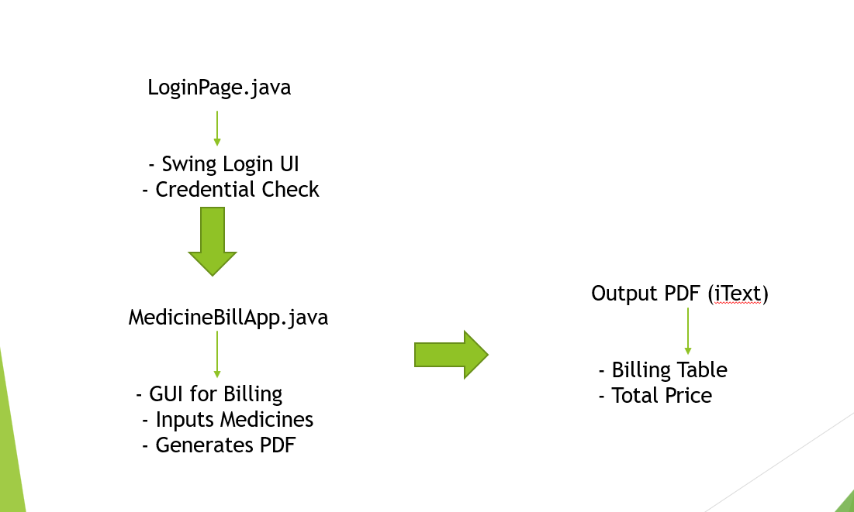

**5.Module description or working of system: Module Description / Working of the System**

**The Pharmacy Billing System is divided into several functional modules that work together to streamline the medicine billing process. Each module is implemented using core Java concepts and GUI components, ensuring both modularity and ease of use. The following is a breakdown of the system's working and individual module functionalities:**

**1. Login Module**

* **Purpose: Ensures basic authentication before accessing the system.**
* **Working:**
  + **Displays a login window with username and password fields.**
  + **Verifies credentials against hardcoded values (e.g., username = "dypcet", password = "dypcet").**
  + **On successful login, opens the billing window; otherwise, shows an error message.**

**2. Billing Input Module**

* **Purpose: Collects billing information from the user.**
* **Working:**
  + **Prompts for customer name and number of medicines to be billed.**
  + **Dynamically asks the user to enter medicine details (Medicine ID, Name, Quantity, and Price per unit) for each item using input dialogs.**
  + **Stores all input data in a 2D array for further processing.**

**3. Calculation and Validation Module**

* **Purpose: Calculates total amounts and ensures valid input.**
* **Working:**
  + **Validates numeric input for quantity and price using try-catch blocks to catch exceptions like NumberFormatException.**
  + **Multiplies quantity and price to calculate total for each medicine.**
  + **Computes the grand total by summing the totals of all items.**

**4. Invoice Generation Module (PDF Creation)**

* **Purpose: Automatically generates a professional bill in PDF format.**
* **Working:**
  + **Uses the iText library to create a well-formatted PDF.**
  + **Adds customer name, date, a table listing all medicines, their quantity, unit price, and line total.**
  + **Displays the grand total and a thank-you note at the end of the invoice.**
  + **Saves the PDF with a timestamp-based filename for uniqueness and reference.**

**5. GUI Module**

* **Purpose: Provides a user-friendly interface using Java Swing.**
* **Working:**
  + **GUI windows are created using JFrame, JPanel, JLabel, JTextField, JButton, and layout managers.**
  + **Enhances the overall user experience by minimizing the need for command-line interaction.**
  + **Ensures simple navigation and form handling through action listeners.**

**Overall System Flow**

1. **User logs in through the login screen.**
2. **Upon successful login, the billing window opens.**
3. **User enters customer details and the number of medicines.**
4. **The system prompts the user to enter details for each medicine.**
5. **The total cost is calculated, and a PDF invoice is generated and saved.**
6. **A confirmation message is shown once the bill is created.**

**6.Screenshots:**

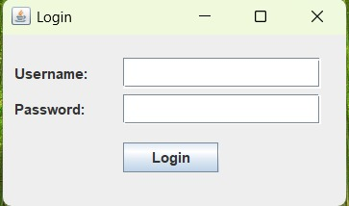

**Login Page**

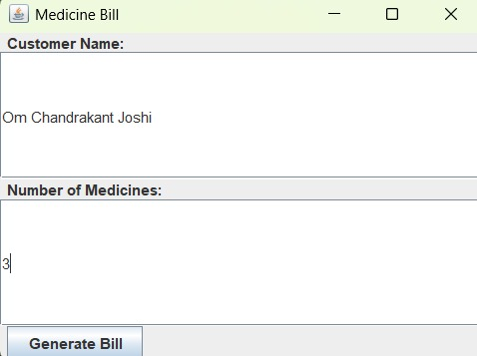

**Medicine bill**

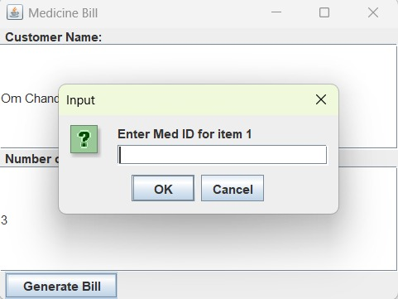

**7.Group Members:**

|  |  |  |  |
| --- | --- | --- | --- |
| **Unique id** | **Roll No** | **Name of Student** | **Sign** |
| **EN** | **111** | **Om Chandrakant Joshi** |  |
| **EN23232422** | **107** | **Vishal Gangadhar Biradar** |  |
| **EN** | **116** | **Atharv Ajit Lite** |  |
| **EN** | **112** | **Gandhar Giridhar Kanade** |  |